1.       
Sales Analysis Dashboard: Create a  
dashboard that shows sales trends over time, by region, and by product category.

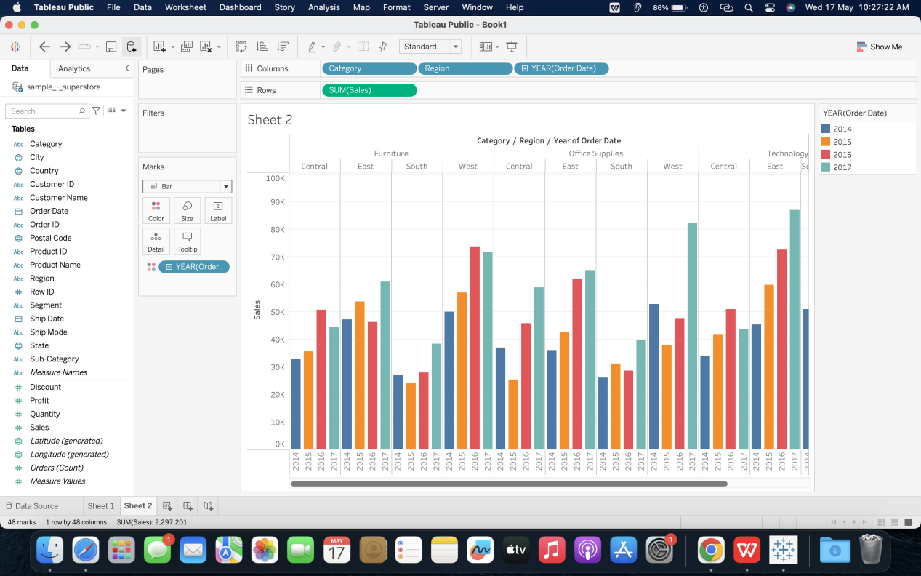

Sales growth rates: